Half Adder (HA) & Full Adder (FA): Standard SOP Form

CPE 133 - 03

Michael Hegglin

Jonathan Skelly

**Objectives:**

* To be introduced to the software and hardware being used during this quarter.
* To design a half-adder, then implement that design into the board with inputs and outputs.

**Procedure:**

The goal of the assignment was to accomplish the below using verilog:

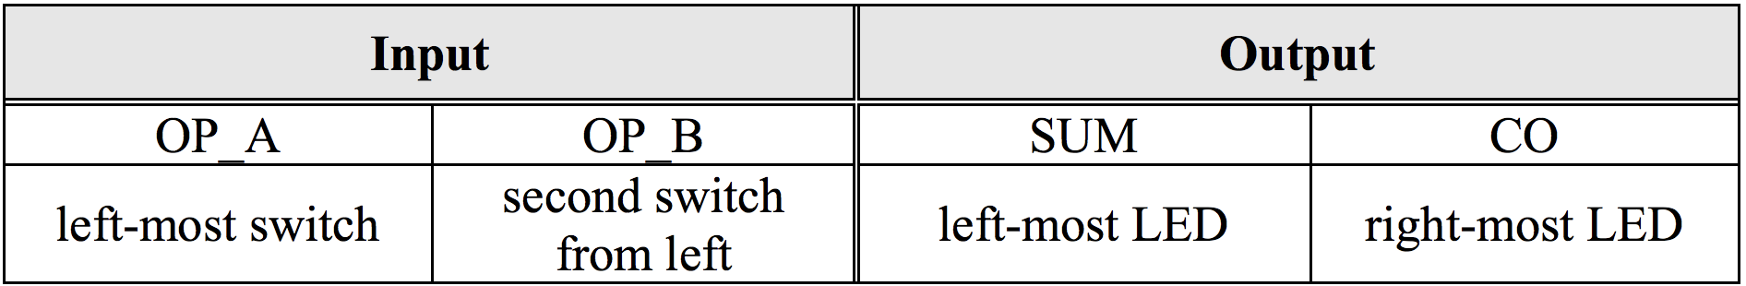

A and B inputs are switches which in turn, turn on the LEDs above the switches. This is achieved through writing and equation for boolean algebra in verilog, and uploading the design to the board. Below is the black box diagram and the equations.

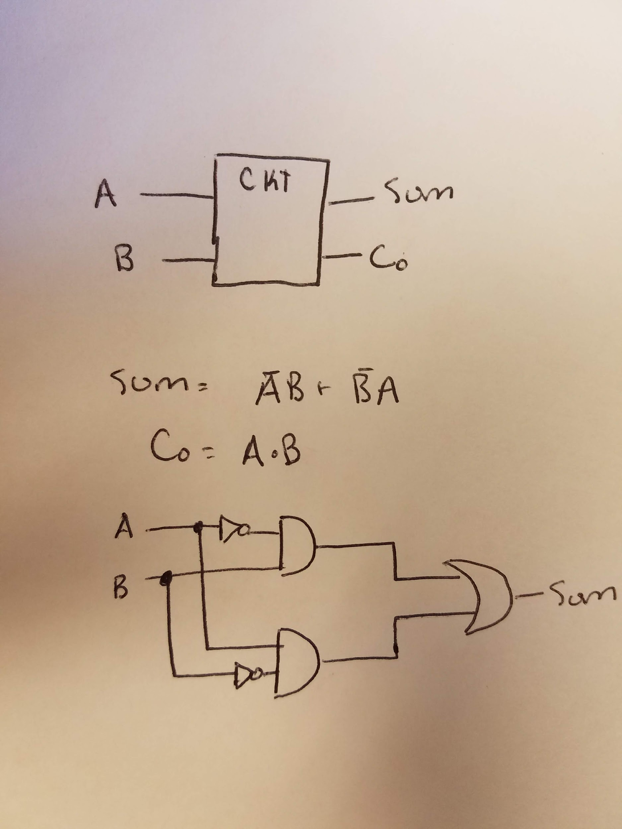

**Testing:**

To test that the board worked correctly, switches were flipped. When one switch was flipped the LED above the switch would turn on. When two switches were flipped, the right most switch would be dark, while the second from the right most switch would be bright. Through visual testing you could see that the carry-over was working along with the sum, due to the fact that you could see the output with the LEDs.

**Conclusion:**

In this experiment a program to see the carry-over and sum could be seen through ones and zeros. This was implemented through verilog software, which was written to a circuit board. This lab solidified the understanding of what the sum and carry-over is. Using the LEDs on the board with the switches a person could see the actual sum and carry-over with the LEDs, instead of 1s and 0s on paper. This experiment acts as the building blocks to further logic when programming hardware. It shows a simple input/output program that is commonly used.

**Questions:**

1. Methodology is a way to find a solution to a problem.
2. The purpose of the constraints file to is correlate the physical parts on the circuit board with the variables in the program.
3. The synthesis step in Verilog transforms the high-level verilog script written by the user into low-level gate logic that the program can easily model.
4. Asdf
5. I used 1 assignment statement in my HDL model for my HA.
6. The limit of an HA in respect to an FA is that an HA can only take two inputs and provide two outputs, as opposed to an FA, which can take three inputs and provide 2 outputs. This means an HA can only compute with 2-bit numbers, unlike the 3-bit numbers of the FA.
7. To verify that everything was working, a person can visually see that the LEDs turn on when flipping the switches.
8. The main purpose of a gate is to perform a logic/boolean function on a given input, and produce a given output dependent on the type of gate. These gates can thereby be used to compute, filter, or accomplish various digital tasks.

**Source code :**

module half_adder(

input a,

input b,

output sum,

output co);

assign sum = (~a & b) | (a & ~b);

assign co = (a & b);

endmodule